**Export Data using the Export Wizard.**

1. Select the database to be exported in the Object Explorer. Right click the database and select the “Tasks” option. Select “Export Data…” option.

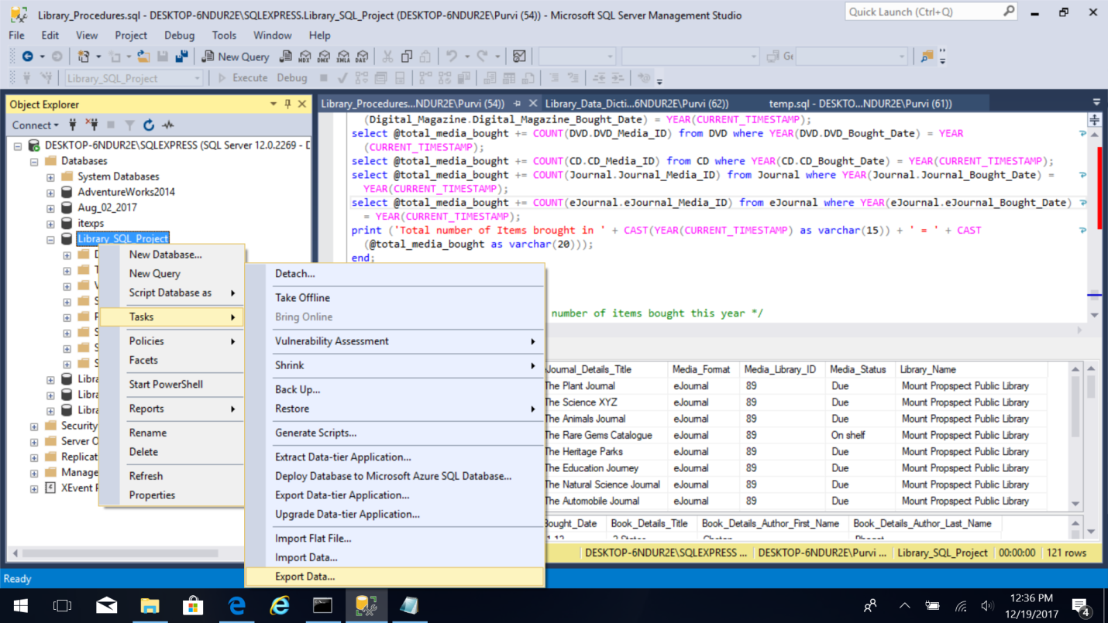

1. Select “Next” on the screen.

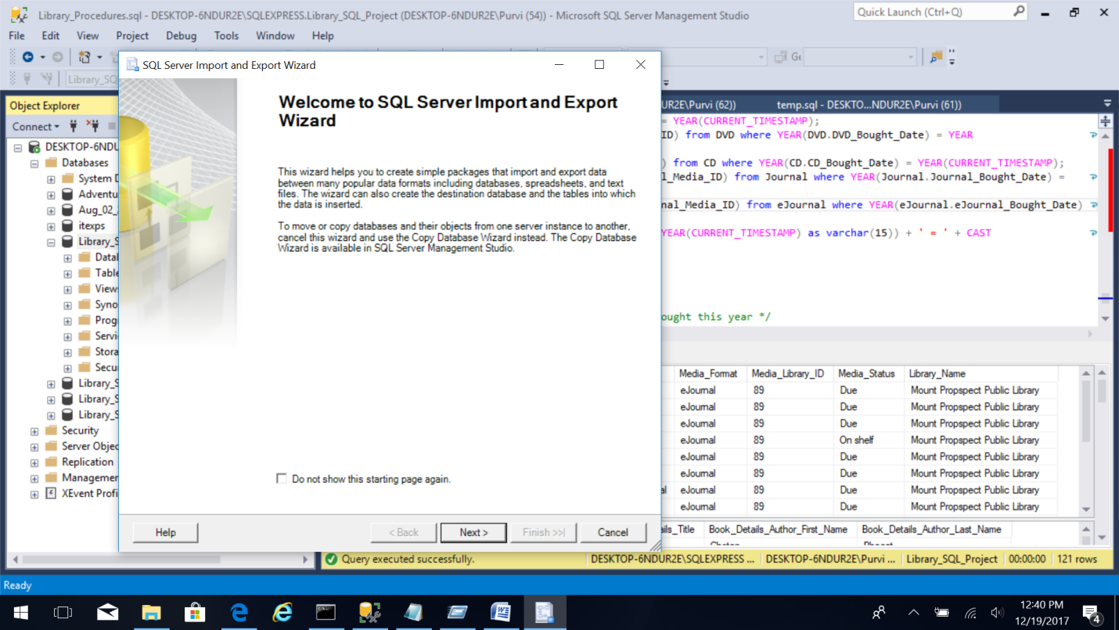

1. Select the Data Source as “SQL Server Native Client 11.0”, Server Name “Desktop-6NDure\SQLEXPRESS”. Use Authentication as “Use Windows Authentication”. Select the database to be exported, in this case “Library_SQL_Project”. Click “Next”.

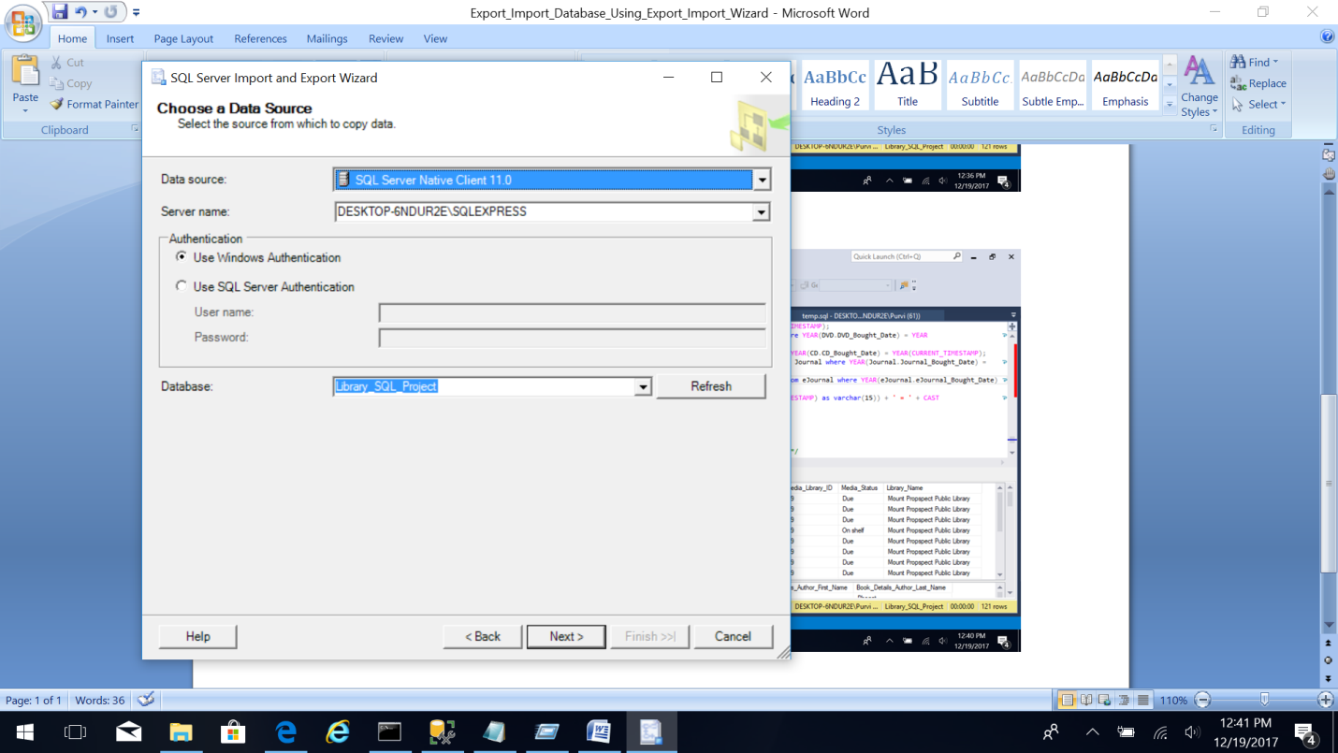

1. Select the Destination as “Microsoft Excel”, specify the path of excel file to be exported and select the excel version. Keep the “First row has column name” option checked. Click “Next”.

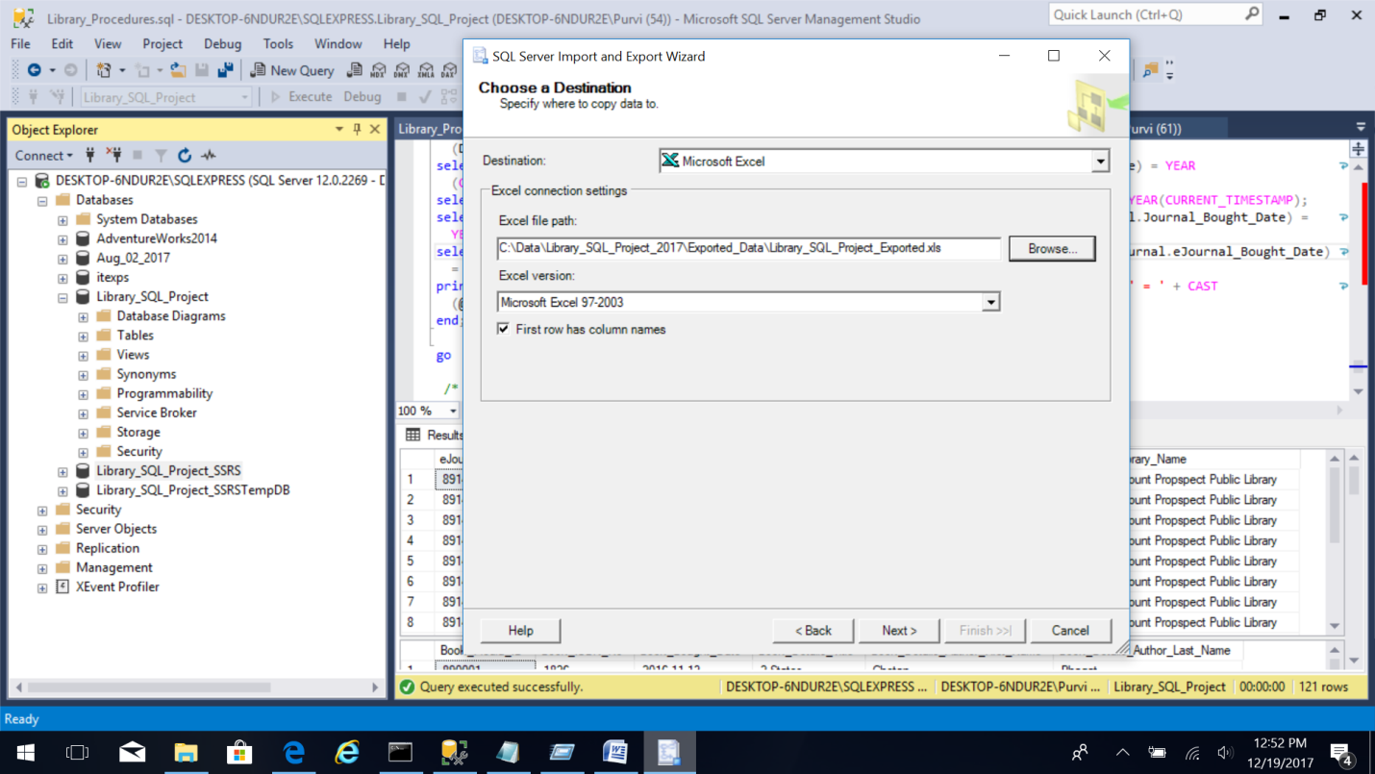

1. Select “Copy data from one or more tables or views” option in the Specify Table Copy or Query.

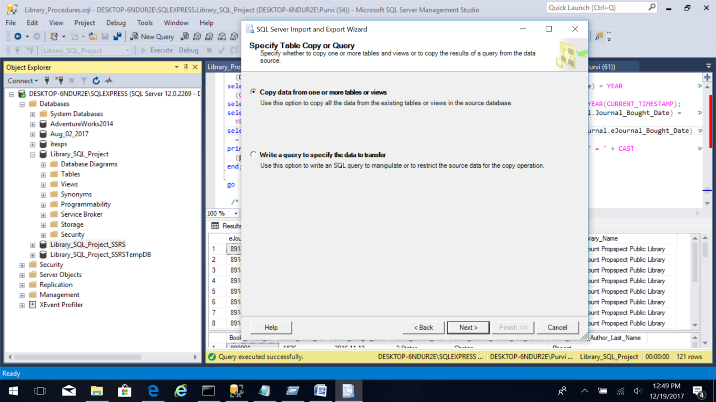

Click “Next”.

1. Select all the tables or views to be exported in this screen.

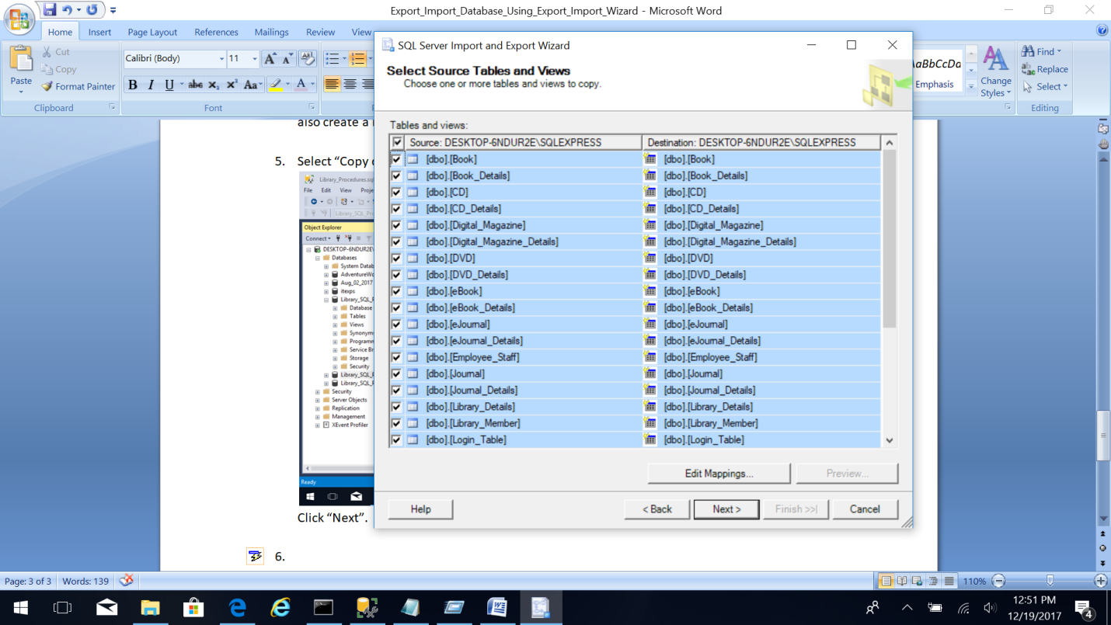

1. Review the data types to map those in the destination and how it handles conversion issues. Click Next.

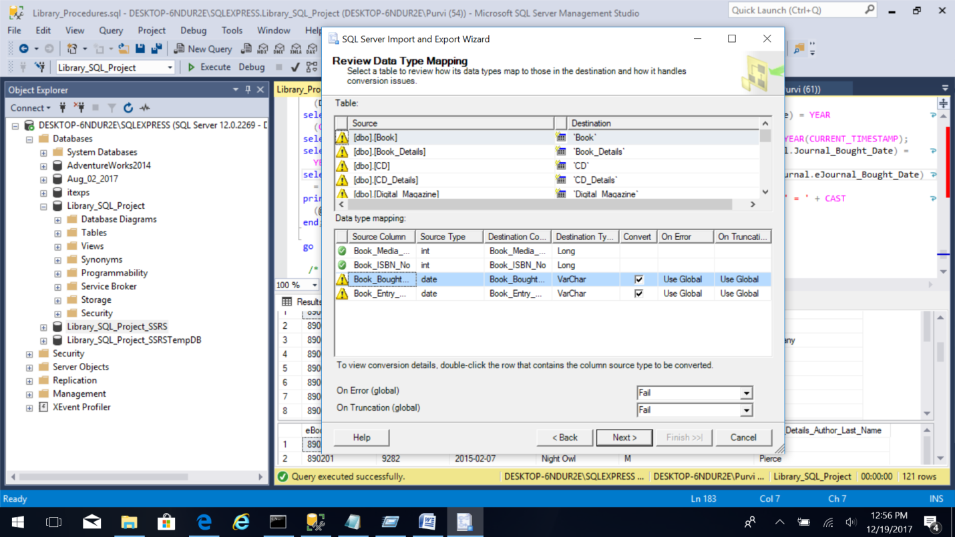

1. In this screen select the option of “Run Immediately”. Click Next.

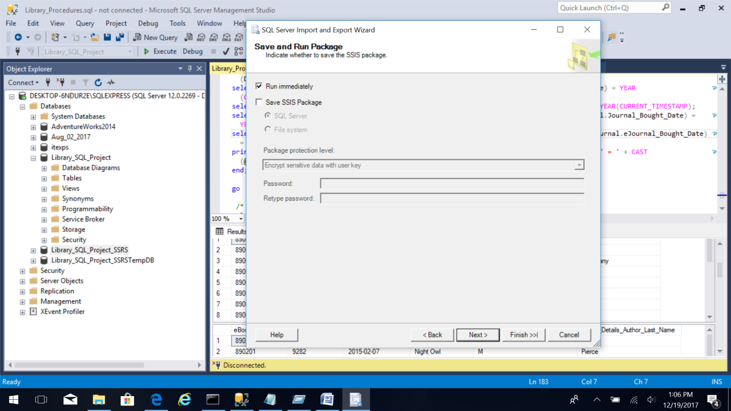

1. Click “Finish” to complete the export wizard process.

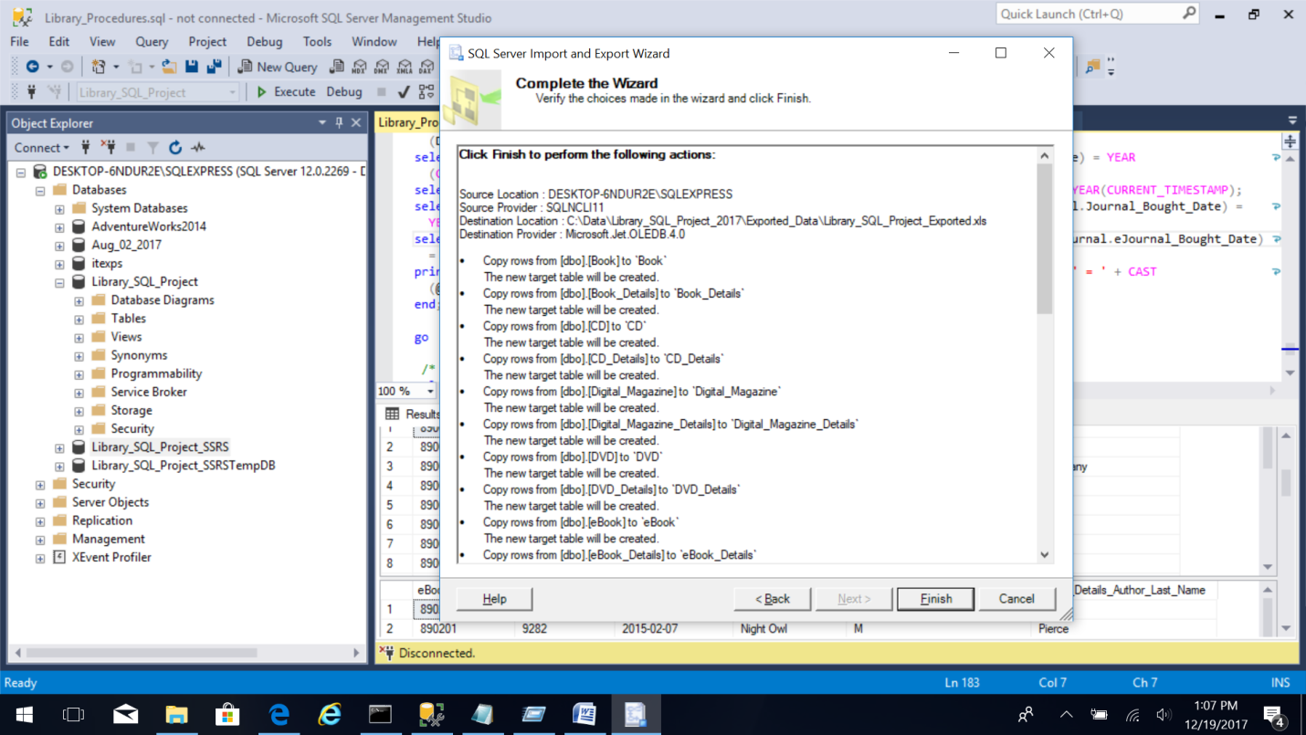

1. You will see the following screen with the export task in process.

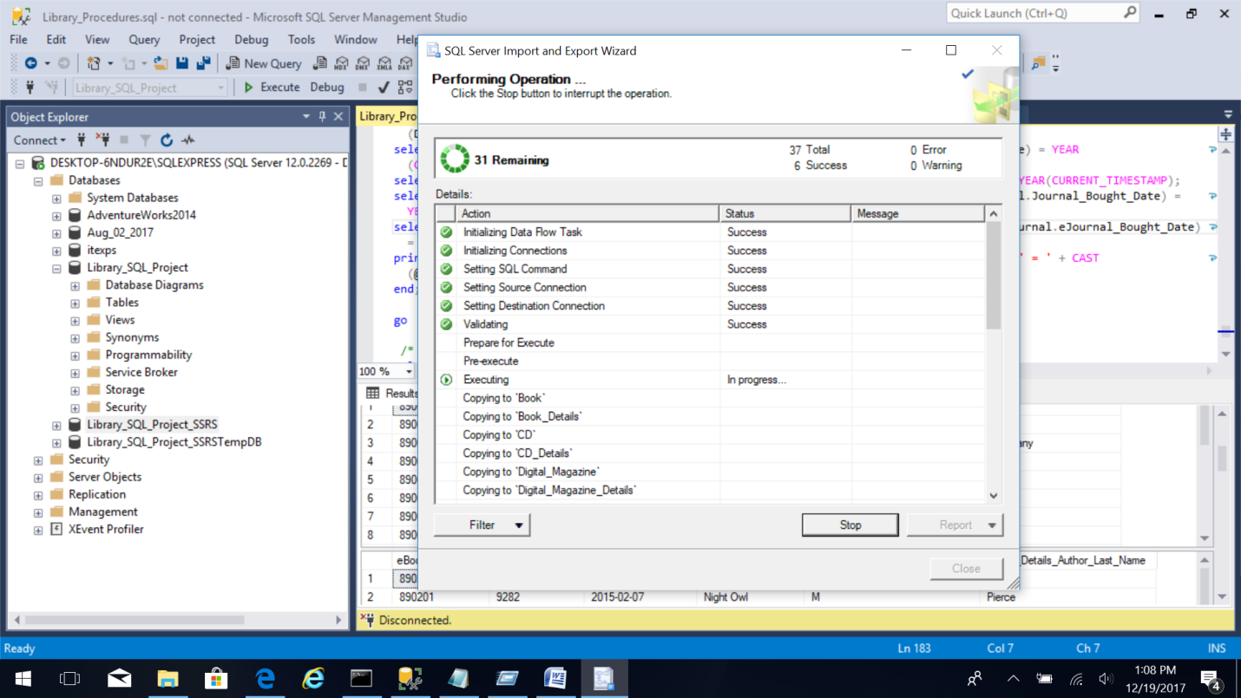

1. After the export task is completed you can review the warnings, errors if any.

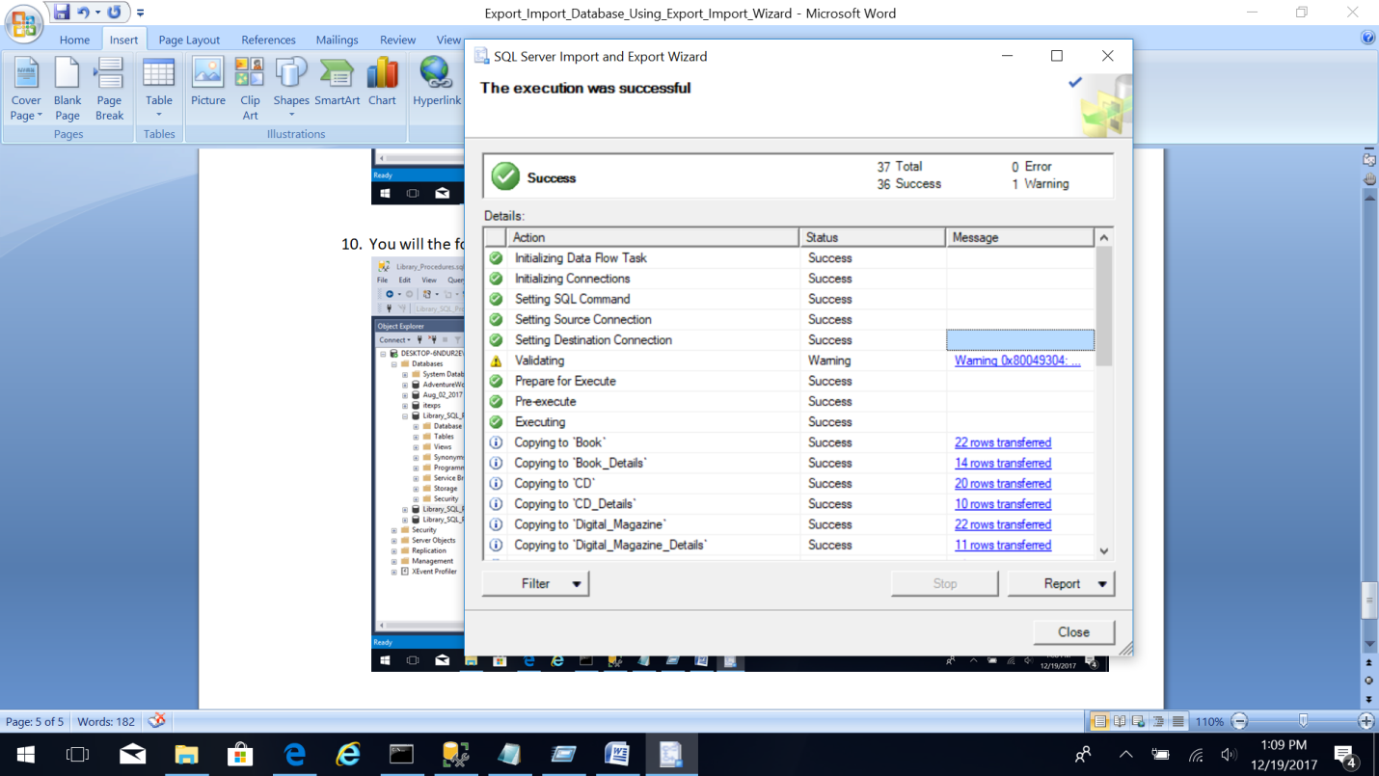

1. Open the Excel file to review the fields exported.

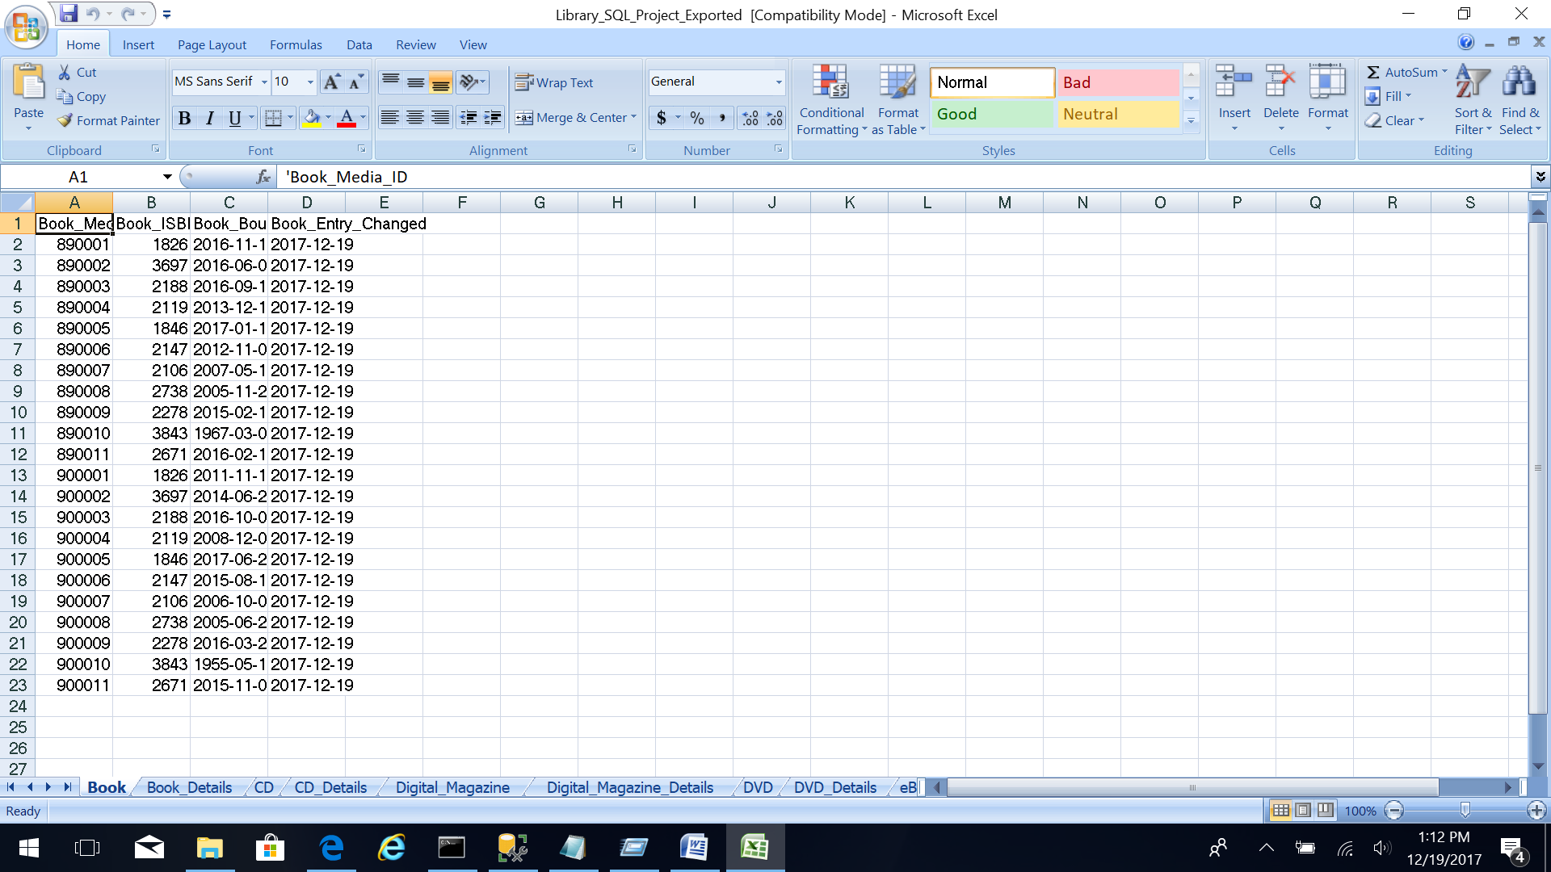

**Import Data using the Import Wizard**

1. Create a new database or select an empty database to import data in the Object Explorer. Right click the database and select the “Tasks” option. Select “Import Data…” option.

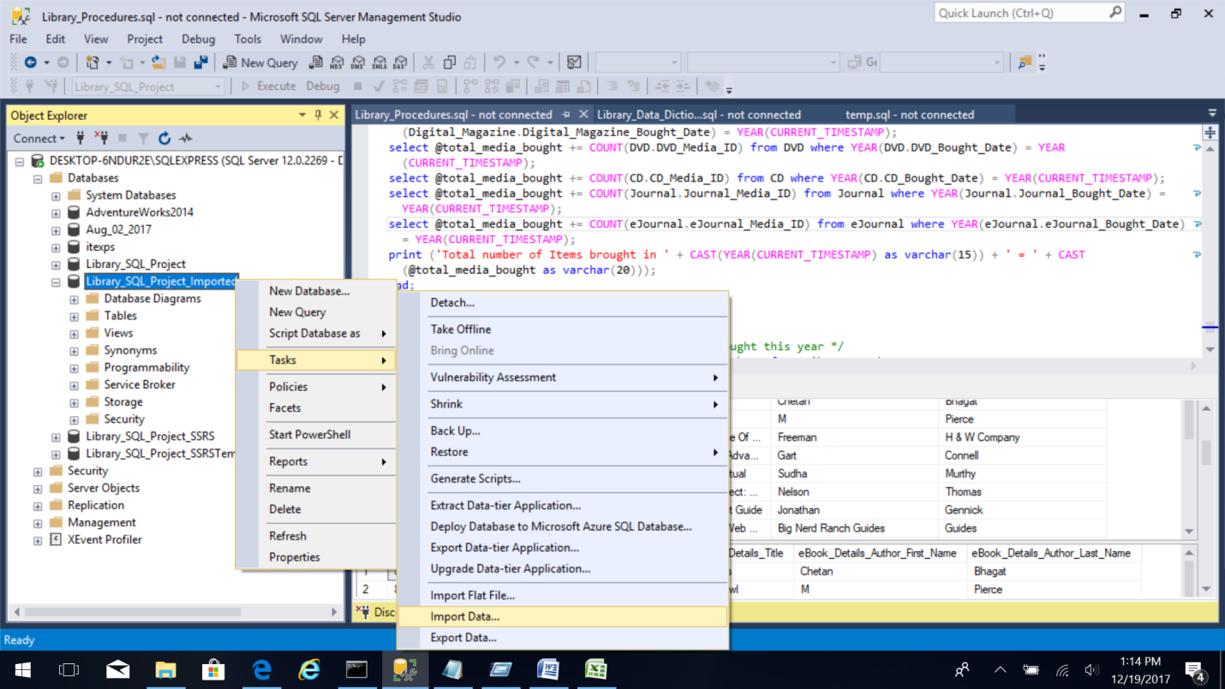

1. Select “Next” on the screen.



1. Select the Data Source as “Microsoft Excel”. Specify the Excel file path and specify the Excel version. Keep the “First row has column names” option checked. Click “Next”.

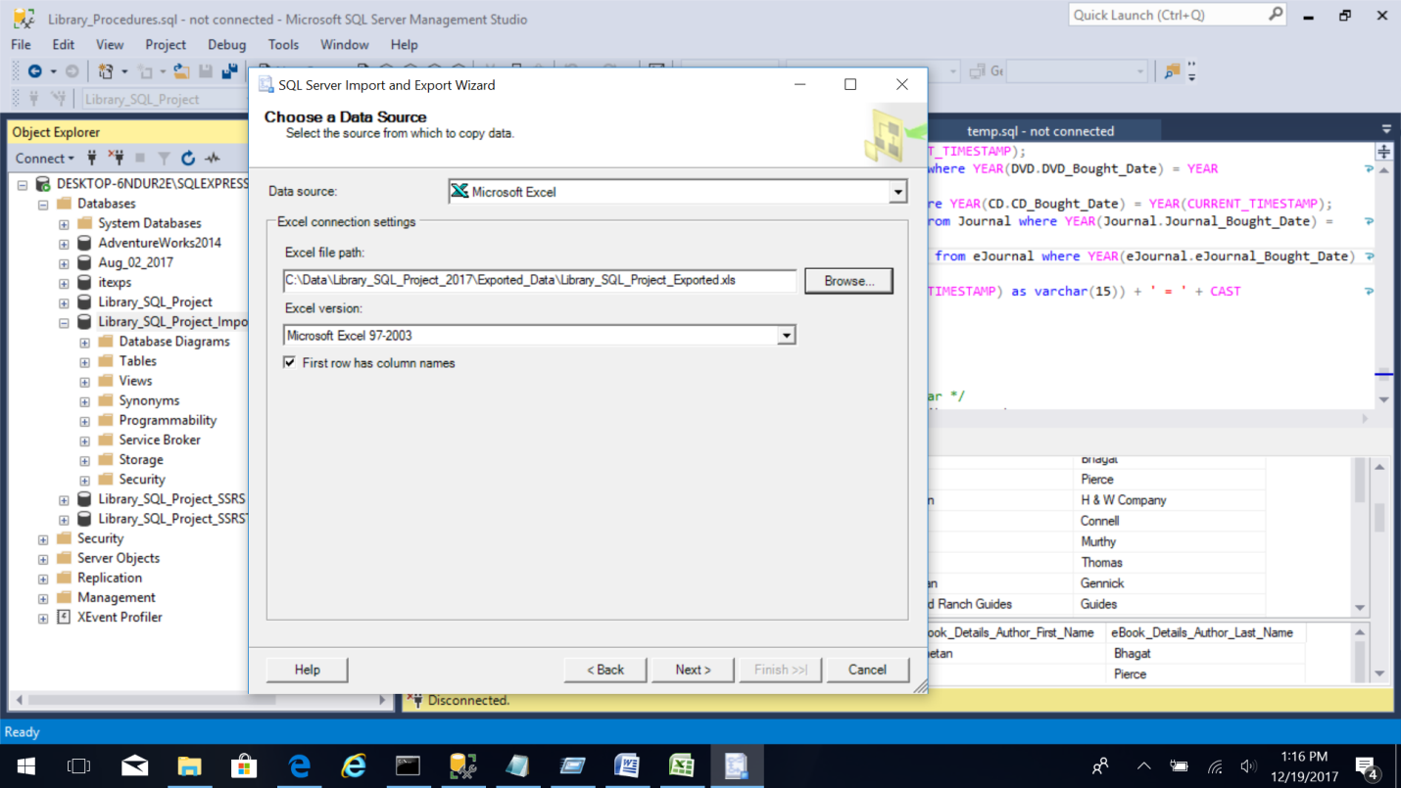

1. Select the Destination as “SQL Server Native Client 11.0”, specify the Server name and select “Use Windows Authentication”, and specify the Database as “Library_SQL_Project_Imported”. You can also create a new database here to import data. Click “Next”.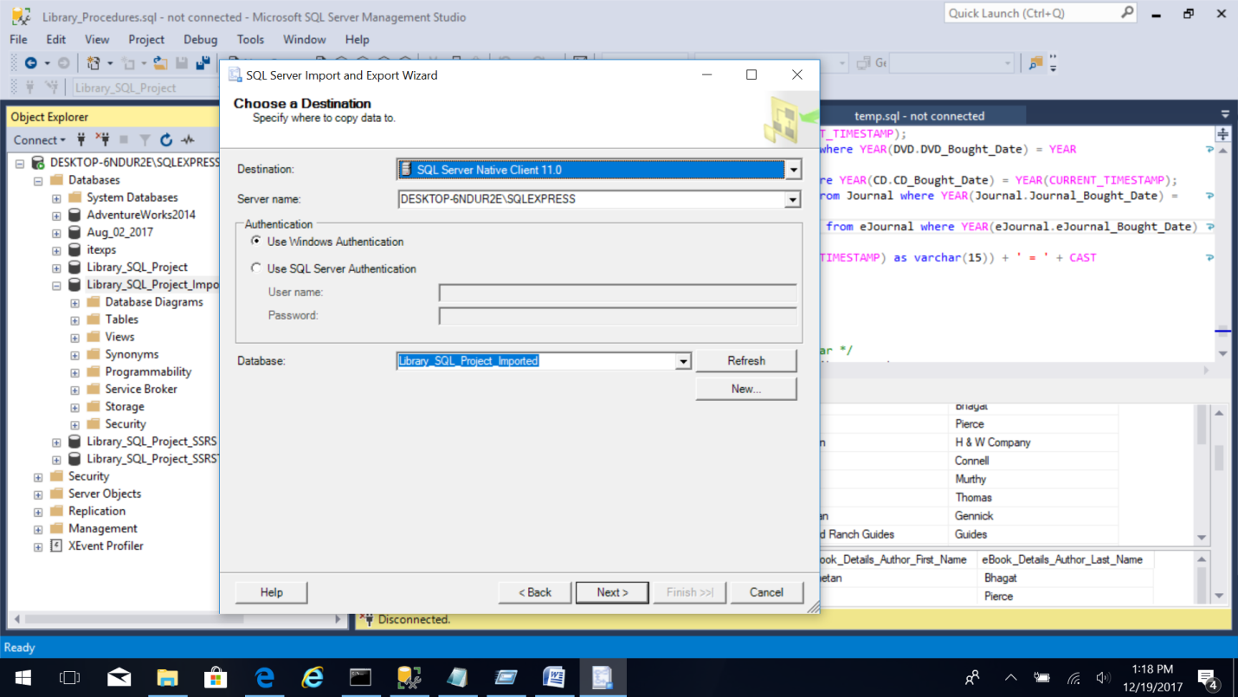
2. Select “Copy data from one or more tables or views” option in the Specify Table Copy or Query.



Click “Next”.

1. Select Source Tables and Views to be imported. Click “Next”.

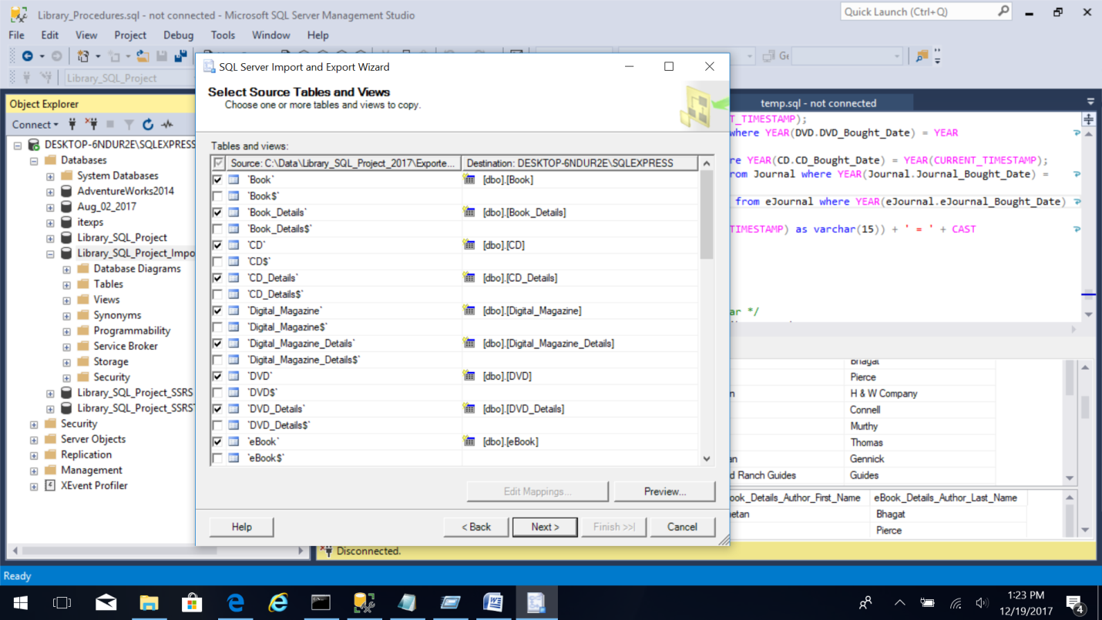

1. In this screen select the option of “Run Immediately”. Click Next.



1. Click “Finish” to complete the import process. 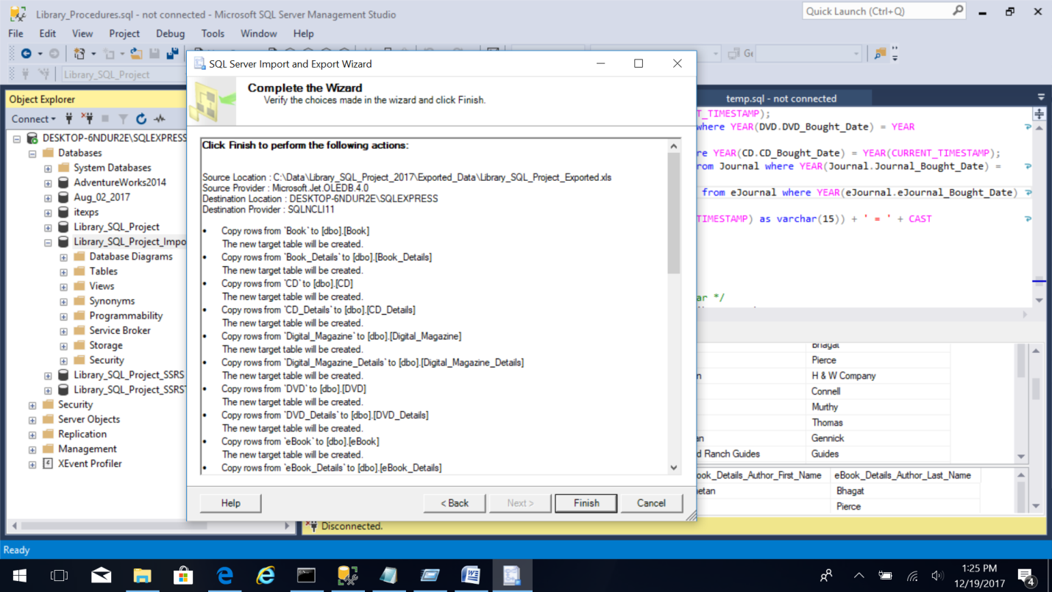
2. You will see the following screen with the export task in process. 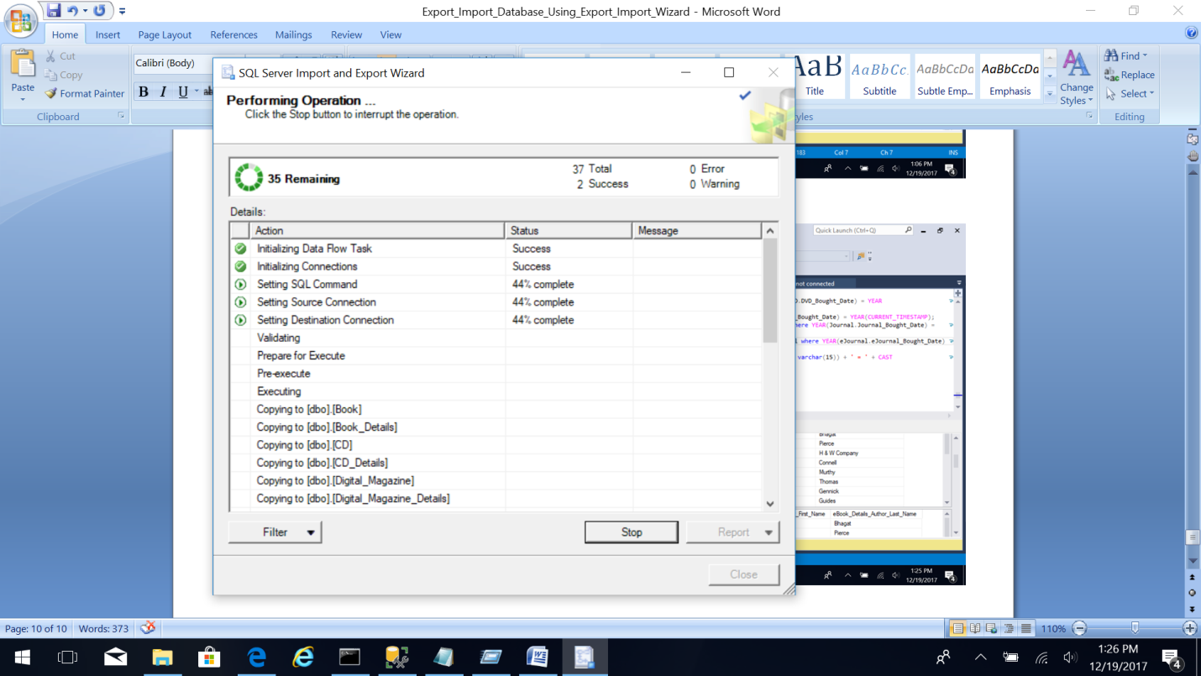

1. After the import task is completed you can review the warnings, errors if any. 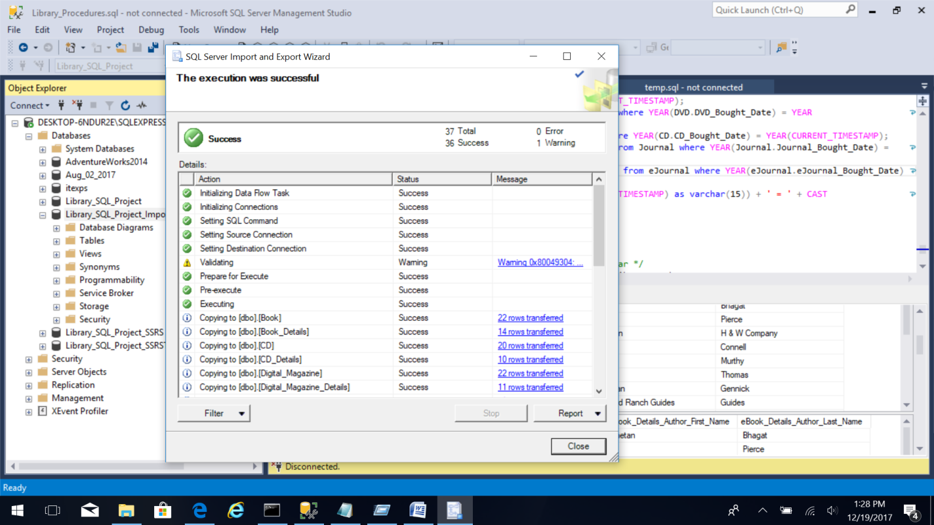
2. View the imported database in the Object Explorer. 